December 22, 2025

Dear Local R7-167 Members:

Nominations are now open for the election of officers for NAGE/IAEP Local R7-167. All nominations must be made on the Nomination/Acceptance Form and must be submitted to Secretary Amanda Layne. They can be mailed to the local P.O. Box, emailed to ajlayne0248@gmail.com or interoffice mailed to Amanda Layne at the Mounds View Base. Nomination/Acceptance Forms must be received on or before January 16, 2026.

Elections will be completed through electronic voting in accordance with our By Laws. Please ensure that we have your correct email address. If we do not have an email address on file for you, electronic voting instructions will be mail out to your home address. Results of the elections will be announced at the First Quarter General Membership Meeting in February 2026.

The Local Executive Board offices that are up for elections are President, District Vice President Metro Emergency Medical Technicians and District Vice President Glencoe/Hutchinson. All positions are three years terms.

All candidates must be members in good standing for one (1) year. A person nominated for more than one position must select the office of his or her choice; no person may run for more than one office.

- Self-nominations are considered accepted upon the Election Officer’s receipt of the Nomination/Acceptance Form on or before January 16, 2026.

- All nominations must be seconded by a union member prior to submission.

- All nominations not received by January 16, 2026, will be considered a nullity.

Sincerely,

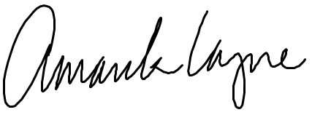

Amanda Layne
IAEP 167 Secretary

