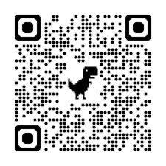
Store Closes
6/11/2026

https://stores.inksoft.com/WS136917

SCAN QR CODE OR CLICK LINK TO SHOP
